ASP.NET MVC Core

Dependency injection into views

ASP.NET Core supports dependency injection into views. This can be useful for view-specific services, such as localization or data required only for populating view elements. You should try to maintain separation of concerns between your controllers and views. Most of the data your views display should be passed in from the controller.

# A Simple Example

You can inject a service into a view using the @inject directive. You can think of @inject as adding a property to your view, and populating the property using DI.

## The syntax for @inject:

@inject <type> <name>

## An example of @inject in action:

|  |  |
| --- | --- |
|  | @using System.Threading.Tasks  @using ViewInjectSample.Model  @using ViewInjectSample.Model.Services  @model IEnumerable<ToDoItem>  @inject StatisticsService StatsService  <!DOCTYPE html>  <html>  <head>  <title>To Do Items</title>  </head>  <body>  <div>  <h1>To Do Items</h1>  <ul>  <li>Total Items: @StatsService.GetCount()</li>  <li>Completed: @StatsService.GetCompletedCount()</li>  <li>Avg. Priority: @StatsService.GetAveragePriority()</li>  </ul>  <table>  <tr>  <th>Name</th>  <th>Priority</th>  <th>Is Done?</th>  </tr>  @foreach (**var** item **in** Model)  {  <tr>  <td>@item.Name</td>  <td>@item.Priority</td>  <td>@item.IsDone</td>  </tr>  }  </table>  </div>  </body>  </html> |
|  |  |

This view displays a list of ToDoItem instances, along with a summary showing overall statistics. The summary is populated from the injected StatisticsService. This service is registered for dependency injection in ConfigureServices in *Startup.cs*:

|  |  |
| --- | --- |
|  | *// For more information on how to configure your application, visit http://go.microsoft.com/fwlink/?LinkID=398940*  **public** **void** **ConfigureServices**(IServiceCollection services)  {  services.AddMvc();  services.AddTransient<IToDoItemRepository, ToDoItemRepository>();  services.AddTransient<StatisticsService>();  services.AddTransient<ProfileOptionsService>(); |
|  |  |

The StatisticsService performs some calculations on the set of ToDoItem instances, which it accesses via a repository:

|  |  |
| --- | --- |
|  | **using** System.Linq;  **using** ViewInjectSample.Interfaces;  **namespace** ViewInjectSample.Model.Services  {  **public** **class** **StatisticsService**  {  **private** **readonly** IToDoItemRepository _toDoItemRepository;  **public** **StatisticsService**(IToDoItemRepository toDoItemRepository)  {  _toDoItemRepository = toDoItemRepository;  }  **public** **int** **GetCount**()  {  **return** _toDoItemRepository.List().Count();  }  **public** **int** **GetCompletedCount**()  {  **return** _toDoItemRepository.List().Count(x => x.IsDone);  }  **public** **double** **GetAveragePriority**()  {  **if** (_toDoItemRepository.List().Count() == 0)  {  **return** 0.0;  }  **return** _toDoItemRepository.List().Average(x => x.Priority);  }  }  } |

The sample repository uses an in-memory collection. The implementation shown above (which operates on all of the data in memory) is not recommended for large, remotely accessed data sets.

The sample displays data from the model bound to the view and the service injected into the view:

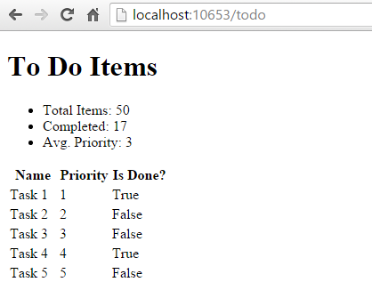

# Populating Lookup Data

View injection can be useful to populate options in UI elements, such as dropdown lists. Consider a user profile form that includes options for specifying gender, state, and other preferences. Rendering such a form using a standard MVC approach would require the controller to request data access services for each of these sets of options, and then populate a model or ViewBag with each set of options to be bound.

An alternative approach injects services directly into the view to obtain the options. This minimizes the amount of code required by the controller, moving this view element construction logic into the view itself. The controller action to display a profile editing form only needs to pass the form the profile instance:

|  |  |
| --- | --- |
|  | **using** Microsoft.AspNetCore.Mvc;  **using** ViewInjectSample.Model;  **namespace** ViewInjectSample.Controllers  {  **public** **class** **ProfileController** : Controller  {  [Route("Profile")]  **public** IActionResult **Index**()  {  *// TODO: look up profile based on logged-in user*  **var** profile = **new** Profile()  {  Name = "Steve",  FavColor = "Blue",  Gender = "Male",  State = **new** State("Ohio","OH")  };  **return** **View**(profile);  }  }  } |

The HTML form used to update these preferences includes dropdown lists for three of the properties:

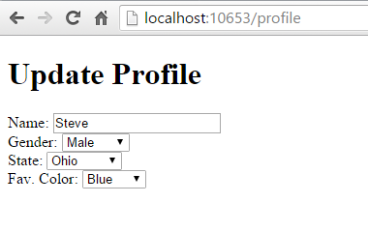

These lists are populated by a service that has been injected into the view:

|  |  |
| --- | --- |
| 28  29  30 | @using System.Threading.Tasks  @using ViewInjectSample.Model.Services  @model ViewInjectSample.Model.Profile  @inject ProfileOptionsService Options  <!DOCTYPE html>  <html>  <head>  <title>Update Profile</title>  </head>  <body>  <div>  <h1>Update Profile</h1>  Name: @Html.TextBoxFor(m => m.Name)  <br/>  Gender: @Html.DropDownList("Gender",  Options.ListGenders().Select(g =>  **new** **SelectListItem**() { Text = g, Value = g }))  <br/>  State: @Html.DropDownListFor(m => m.State.Code,  Options.ListStates().Select(s =>  **new** **SelectListItem**() { Text = s.Name, Value = s.Code}))  <br />  Fav. Color: @Html.DropDownList("FavColor",  Options.ListColors().Select(c =>  **new** **SelectListItem**() { Text = c, Value = c }))  </div>  </body>  </html> |

The ProfileOptionsService is a UI-level service designed to provide just the data needed for this form:

|  |  |
| --- | --- |
|  | **using** System.Collections.Generic;  **namespace** ViewInjectSample.Model.Services  {  **public** **class** **ProfileOptionsService**  {  **public** List<**string**> ListGenders()  {  *// keeping this simple*  **return** **new** List<**string**>() {"Female", "Male"};  }  **public** List<State> ListStates()  {  *// a few states from USA*  **return** **new** List<State>()  {  **new** **State**("Alabama", "AL"),  **new** **State**("Alaska", "AK"),  **new** **State**("Ohio", "OH")  };  }  **public** List<**string**> ListColors()  {  **return** **new** List<**string**>() { "Blue","Green","Red","Yellow" };  }  }  } |

**Tip**

Don’t forget to register types you will request through dependency injection in theConfigureServices method in *Startup.cs*.

# Overriding Services

In addition to injecting new services, this technique can also be used to override previously injected services on a page. The figure below shows all of the fields available on the page used in the first example:

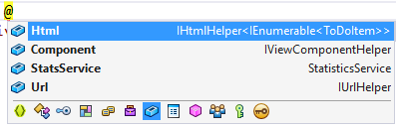

As you can see, the default fields include Html, Component, and Url (as well as the StatsServicethat we injected). If for instance you wanted to replace the default HTML Helpers with your own, you could easily do so using @inject:

|  |  |
| --- | --- |
|  | @using System.Threading.Tasks  @using ViewInjectSample.Helpers  @inject MyHtmlHelper Html  **<!DOCTYPE html>**  <html>  <head>  <title>My Helper</title>  </head>  <body>  <div>  Test: @Html.Value  </div>  </body>  </html> |

If you want to extend existing services, you can simply use this technique while inheriting from or wrapping the existing implementation with your own.